DIGI PHOTO
ART 263 with Andrew Douglas Campbell (SSH 120 B)
Campbea@linnbenton.edu
Office Hours: Tuesday & Thursday 4-5pm and by appointment (SSH 115)

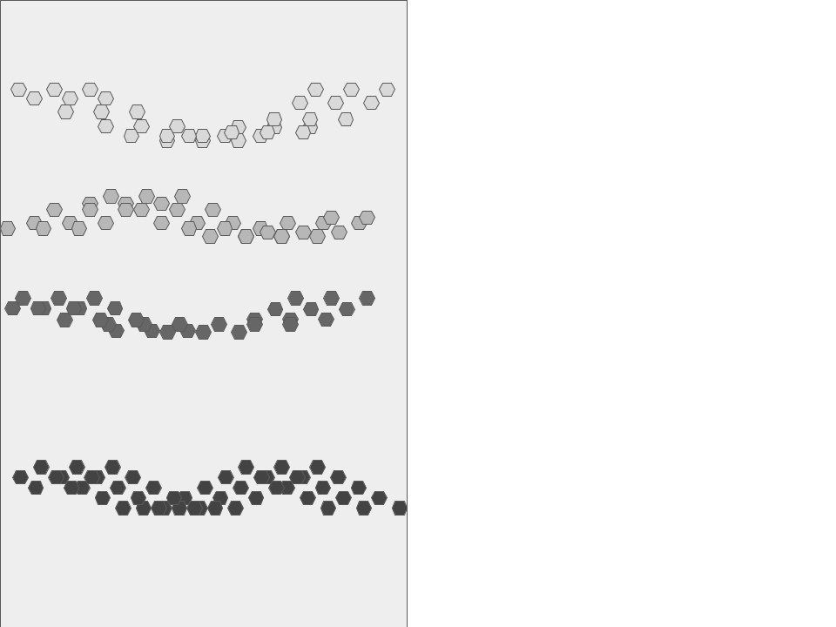
What to expect:
I will post new class content to Moodle every Monday. We will meet every Tuesday and Thursday for group discussions, demos, and individual help. You are free to complete remote lessons in your own time. Most weeks include an art lecture, a technical demo, and a workshop.

We will meet in the digital arts labs (SSH120) each Tuesday and Thursday. We will cover technical demos, troubleshoot design problems, and hold open studio time. We will have discussions of lectures, readings, and/or critiques together during our classes.

Over the course of the term we will practice a number of technical skills, we will look at a wide range of artists for insight and inspiration, and we will complete 3 large scale projects

The school requires that all correspondence take place through the email address and moodle account provided by LBCC. I heavily filter my LBCC inbox, so if you try to contact me from a non-LBCC email address you’ll likely be sent straight to spam.

What are we doing here?
ART 263: Digital Photography is a course in digital imaging as an expressive medium; in other words we take pictures to share beautiful pictures. We'll practice shooting and editing photographs with Digital Tools. We’ll emphasize both formal and conceptual expression.

What will we learn?

We’re going to accomplish these technical skills:
- Successfully expose, download, and edit a digital image.
- Accomplish basic to intermediate digital manipulation techniques.
- Produce photo quality digital prints
- Operate in utilize a flatbed scanner
- Examine the form and content of specific digital images relative to the cultures that produced them.
Alongside technical learning we’ll think about photography conceptually: We will look at lots of art, from a range of contexts and perspectives. We will make lots of art. We’ll ask “Hey camera, why are you like that? What role does the (camera) lens play in defining meaning? Hey lens, why are you so powerful and how’d you get that way?”

We’re gonna practice the practical skills of making photos. And we’re gonna practice the conceptual skills of making meaning. We will read about and talk about images in culture, and the culture of images.

What will I need for class?
- Digital SLR camera (your own or checked out from LBCC) SD Card (8GB+)
- A working home computer with the capability of running Adobe Creative Cloud (chromebooks are great but do run our software)
- A reliable home internet connection
- You are not required to have external storage for your images, but it is recommended to store your images on an external backup drive.

Moodle + Google Drive:
We will primarily use Moodle for this course. All homework and workshops will be submitted on Moodle, and you will also find all course material like lectures, slideshows, and other resources. We also have a shared Google-Drive for this course, we will use it as a back-up to Moodle and to share some of the larger files we make.

How is classwork handled?

Almost all classwork is due before midnight Monday night. Even if the work is not finished, submit what you have before midnight Monday. There is no penalty for submitting incomplete work, and I will gladly help you finish it up.

What is expected of me?

Attendance & Participation
Attend every class. That is the ideal. Obviously ideals are rare, and we are amid an ongoing health crisis, so I’ll try to make the attendance policy match the circumstances.

Attendance does not affect your grade, participation does:
- If you're unsure about your health, then feel free to stay home.
- If you are away from class, you are expected to keep up on class work and participate in workshops and discussions. This can happen via Email, Zoom, or at Office Hours
- I will take attendance during each class, this is only to help track participation, for outreach purposes, and for contact tracing if covid exposure happens.
- All lectures will be recorded and available on moodle.

For homework, I recommend setting up a schedule for yourself; blocking out dedicated time to focus on lectures and workshops uninterrupted. This means closing out all socials, chat windows, and silencing phones for a specific amount of time. The quality of work improves when it is given dedicated time and focus; this fact is supported by research.
Eat a good breakfast, get enough sleep, and bring coffee, tea, water, nuts, dried fruit, etc.

Your Power & Your Responsibility

You will be designing and presenting images and that is a very powerful act. As a designer of images, you have an immense responsibility. Racism, sexism, anti-queer rhetoric, and other forms of discrimination will not be humored in this room. We reserve no space for words, speech, behavior, actions, or clothing/possessions that insult, diminish, demean, belittle, or threaten any individual or group of persons based on race, ethnicity, religion/faith, gender identity and expression, sexual orientation, ability, economic class, national origin, language, age, or other considerations. Forbidding discrimination is different than a critical engagement with realities of racism, sexism, transphobia, homophobia, xenophobia, etc. We must recognize that the line between what is discrimination and what is critically engaging can be a fuzzy, and requires empathetic, calm discourse. If you are uncertain about the content of your work, speak with me about it before sharing it with the class. I promise to review your project with you in good faith and help you with any tricky content. Work submitted for this class that violates this policy will receive a ‘zero' without the possibility of revision.

Expectations Regarding Pronouns
Within the context of this class, we will refer to one another with pronouns in place of names. Like names, pronouns are an important part of how we identify that deserve to be respected. Making assumptions about someone’s gender can be hurtful, especially our trans and enby pals. Everyone in class is expected to use pronouns shared by their classmates and instructors.

Expectations Regarding children of students
We respect parents in school, and know that higher education structures and schedules were not designed with parents in mind. When your child’s needs mean that you must be away from class, or if your child’s schedule has them join you in class, we will make arrangements that suit your situation. Just let me know.
*one more note on children in the classroom: though I know and respect that children must be considered when parents are in school, this class was designed for adults and the topics we cover and discuss will not always be appropriate for children or younger audiences, so please touch base with me if a child is going to be present for a lecture or class discussion.

How is this class evaluated?

- 20% - Workshops (weekly in-class exercises)
- 20% - Project 1 (Space is the Place)
- 20% - Project 2 (Dreams are Made of This)
- 20% - Project 3 (A Total Portrait)
- 20% - Reading/Writing (in 3 parts over the term)
All 3 projects include a transparent rubric for success. Our assingments should never be confusing or a mystery, if anything is ever unclear please ask for more info. My goal is your success.

Not happy with a grade? REVISE IT!!!
All assignments are open to revision at any time throughout the term. Revised work will be reviewed and considered for a higher grade; revising work will never lower your grade.

What resources are available if I need help?
This is a very cursory list, but it is a place to start:

Me:
I am available to assist you in any way I can. I meet students during regular office hours, and by appointment, and I can be reached via email: Campbea@linnbenton.edu

Campus Resources (with links)

Moodle Support
If you have questions about Moodle or need technical support, contact:
❖ Student Help Desk (in the Library): email student.helpdesk@linnbenton.edu
❖ LBCC Moodle User Support Forum: Look up answers or post questions:
http://elearning.linnbenton.edu/mod/forum/view.php?id=2697

The Learning Center

provides free services designed to boost your college knowledge so that you can achieve the test scores, grades, and goals you want. Through the Learning Center, you can access Tutoring, Academic Coaching, the Writing Center, Math Support, the Science Help Desk, and English Language Support. Visit the Learning Center website to learn more.

Basic Needs Statement
If you are facing difficulties like the loss of a job, new childcare demands, healthcare expenses, or other new strains on your finances and can no longer afford to pay for things like rent, utilities, food, textbooks or other school necessities, we may be able to help.
Single Stop

College Policies

LBCC Email and Course Communications
You are responsible for all communications sent via Moodle and to your LBCC email account. You are required to use your LBCC provided email account for all email communications at the College. You may access your LBCC student email account through Student Email and your Moodle account through Moodle.

Accessibility Statement
LBCC is committed to inclusiveness and equal access to higher education. If you have approved accommodations through the Center for Accessibility Resources (CFAR) and would like to use your accommodations in the class, please talk to your instructor as soon as possible to discuss your needs. If you believe you may need accommodations but are not yet registered with CFAR, please visit the CFAR Website for steps on how to apply for services or call 541-917-4789.

Statement of Inclusion

To promote academic excellence and learning environments that encourage multiple perspectives and the free exchange of ideas, all courses at LBCC will provide students the opportunity to interact with values, opinions, and/or beliefs different than their own in safe, positive and nurturing learning environments. LBCC is committed to producing culturally literate individuals capable of interacting, collaborating and problem-solving in an ever-changing community and diverse workforce.

Veterans
Veterans and active duty military personnel with special circumstances are welcome and encouraged to communicate these, in advance if possible, to the instructor.

