Electrical Troubleshooting
In class activity

- Find the missing values
 | Voltage | Current | Resistance
R₁
R₂
R₃
Total
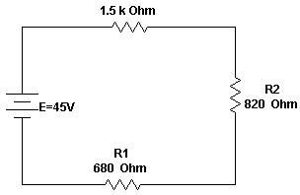

- Find the missing values
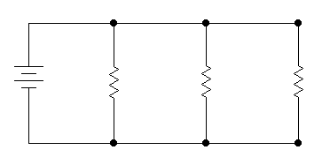
 | Voltage | Current | Resistance | Power
R₁ |  |  | 48Ω
R₂ |  |  | 120Ω
R₃ |  |  | 60Ω
Total | 24V

R1
R2
R3

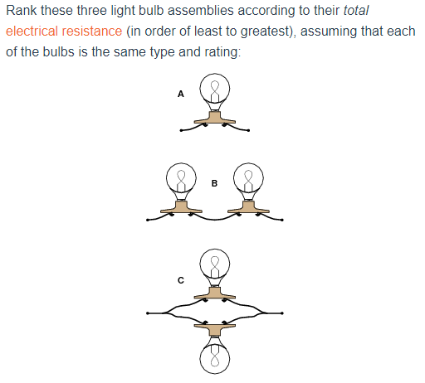

Least: _____
Mid: _____
Most: _____

- Find the missing values

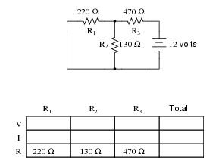

E

